School District 14 Resources
Compiled by your School District 14 Community Education Council (CEC14)
Facebook: @CECd14 | Instagram: @CECd14 | Twitter: @council_14
Phone: 718.302.7624 | Email: cec14@schools.nyc.gov | Website: www.cecdistrict14.com

To receive the latest updates from Notify NYC, text COVID to 692-692, or text COVIDESP to get the same updates in Spanish.

All New York City playgrounds are closed until further notice.

School buildings will likely remain CLOSED for the rest of the 2019-2020 school year
More info here http://schools.nyc.gov/ or call 311

If you are in need of devices for remote learning
- Call the DOE Service desk Monday-Friday, 6am-5pm at 718-935-5100 or call 311
- Go online to: https://coronavirus.schools.nyc/RemoteLearningDevices
- This organization is also sending devices: http://www.globetops.com/get-laptopped/

Attendance
Attendance will not be counted against students at this time, and it will not affect middle school or high school admissions. Students are encouraged to participate online everyday

The New York state English Language Arts and math exams for grades 3-8 have been suspended by the New York State Education Department (NYSED)

Regents exams have been cancelled for June, 2020
Students who planned to take one or more Regents exams in June will be exempt so long as they pass the related course this school year. The same standard applies for students who wanted to take a 4+1 Pathway exam.
- If a student has already passed a course but was planning to take the exam in June, they will also be exempt from the exam.
- If a student fails the course, they must take summer school and pass the class in order to earn the diploma credit by August.
- Students who wanted to retake the test to get a passing score must show/inform their school that they intended to take the June exam, received tutoring or academic intervention to prepare for the test, or have already recently retaken the exam in an attempt to raise their score.
- Districts will still be required to allow students to take the test at a later time if they wish.

Community Resources
YOU DO NOT HAVE TO GIVE IMMIGRATION STATUS TO USE ANY OF THESE SERVICES

Immigrants and public charge
On March 13, US Citizenship and Immigration Services (USCIS) said that seeking or using healthcare services related to COVID-19 will NOT be considered under the public charge rule, even if the services are Medicaid-funded. Anyone who needs help during the COVID-19 crisis should seek care without fear, regardless of immigration status or ability to pay for health services.

DACA Recipients
For help renewing your application call ActionNYC at 1-800-354-0365 (we may even be able to help you out with the renewal fee
Human Resources Administration (HRA)
The New York City Human Resources Administration/Department of Social Services (HRA/DSS) provides New Yorkers in need with essential benefits such as Food Assistance and Emergency Rental Assistance. Available HRA programs:
- SNAP
- TEMPORARY CASH ASSISTANCE
- CAREER SERVICES
- HOMELESSNESS PREVENTION
- ENERGY ASSISTANCE
- WeCARE
- HEALTH INSURANCE
- DOMESTIC VIOLENCE SERVICES
- HIV/AIDS SERVICES ADMINISTRATION
- ADULT PROTECTIVE SERVICES
- HOME CARE/LONG TERM CARE
- CHILD SUPPORT ENFORCEMENT
- IDNYC
For more information on our programs, please call HRA Infoline at 718-557-1399 or 311

For Medicaid Renewal: Call the HRA Medicaid Helpline at 888-692-6116

Senior Citizen Rent Increase Exemption & Disability Rent Increase Exemption (SCRIE/DRIE)
These programs help eligible senior citizens (aged 62 and over) and tenants with qualifying disabilities (aged 18 and over) stay in affordable housing by freezing their rent.
- Call 311

Health care and testing
You should consult with your doctor if you:
- Have fever, cough, shortness of breath or other cold or flu-like symptoms and do not feel better after three to four days
- Have mild symptoms and are an older adult or have any of the chronic health conditions listed above
Use telephone, text, telemedicine or a patient portal to reach out rather than going to your doctor in person. You and your provider will decide if you need to come to medical care.
If you need help finding a health care provider, call 311.

Confidentially self report COVID19 status and symptoms
call 311 or go to nyc.gov/cv19engagementportal

If you see price increases for items in short supply due to COVID-19
report it by calling 311 or online at nyc.gov/dcwp

Mental Health Support New Yorkers Can Access While Staying Home
You can contact NYC Well, a confidential helpline for overwhelming stress, mental health and substance misuse services. Trained counselors can provide you with support 24 hours a day, 7 days a week, in over 200 languages. Services include: Crisis counseling, Peer support, Short-term counseling, Mobile crisis teams,
All services are free to New Yorkers, regardless of insurance coverage or immigration status.
- call 888-NYC-WELL (888-692-9355)
- text “WELL” to 65173
- chat on line, and find apps and online tools at nyc.gov/nycwell

Aging New Yorkers
If you feel lonely or isolated or have questions about mental health services, or are a caregiver with questions call the NYC Department for the Aging hotline at 212-AGING-NYC (212-244-6469)
Veterans
Veterans living in New York, or New Jersey, can get trauma counseling and crisis intervention support. Call 311 to get connected to these services; in an emergency, call 911. Or call the Veterans Crisis Line: 800-273-8255.

Students & Young People
The NYC Department of Youth and Community Development is continuing to provide services for young people in Runaway and Homeless Youth Residences and Drop-In Centers.
- call DYCD Youth Connect at 1-800-246-4646 or 1-646-343-6800
- email DYCDCOVID19@dycd.nyc.gov

Let’s work together to put an end to bias incidents and hate stemming from #COVID19 stigma
- Call 311 to report any COVID19 related discrimination to the New York City Commission on Human Rights.
- Call 911 if you are a victim of or witness a hate crime.

If you believe an employer is violating either existing labor laws or recently issued executive orders
- Call 311 or the New York State Attorney General at (212) 416-8700 or Labor.Bureau@ag.ny.gov to report them.
- Learn more: https://www1.nyc.gov/site/dca/workers/worker-rights.page

People with Disabilities
- ACCESS-A-Ride is no longer scheduling shared rides until further notice.
- NYC Department Of Transportation is extending the all City Parking Permits or Temporary Permits for People with Disabilities that expired or will expire in 2020.
- Residents can call 646-599-9999 to request a wheelchair-accessible taxi from anywhere in the five boroughs.
For specific questions or concerns please contact the Mayor’s Office for People with Disabilities directly:
- Voice Phone: 212-788-2830
- Video Phone: 646-396-5830
- Online: on.nyc.gov/2UN4350

Domestic violence
- In an emergency, dial 911.
- The National Domestic Violence 24-hour hotline is: 1-800-799-7233, or for TTY: 1-800-787-3224.
- The New York State Domestic and Sexual Violence 24-hour hotline is: 1-800-942-6906, or for the deaf or hard of hearing: 711.
- The 24-hour hotline for Safe Horizon, a non-profit serving individuals in New York City is: 1-800-621-4673. TTY 866-604-5350 to speak with a counselor.
- The 24-hour live-operated bilingual (English/Spanish) hotline for the Violence Intervention Program is: 1-800-664-5580.

For anyone needing resources to help themselves or a loved one experiencing dating, domestic, or gender-based violence, you can also visit the NYC Hope Resource Directory at nyc.gov/NYCHOPE.
For immediate safety planning, shelter assistance, mental health support, and other resources, call NYC Family Justice Centers Monday to Friday, from 9am – 5pm. The physical locations of the Family Justice Centers are temporarily closed.
- Brooklyn: 718-250-5113
During evenings and weekends, call NYC’s 24-hour hotline: 1-800-621-4673

24/7 Rape and Sexual Assault Hotline: 1-212-227-3000
Chat with an advocate: visit Safehorizon.org/SafeChat

Assistance for anyone impacted by crimes, including support for family members of homicide victims. Hours are Mon – Fri, 9am – 5pm at 1-855-234-1042

Section 8 Participants
NYCHA is suspending all termination actions while the City is under a state of emergency, but at a minimum, 60 days. Families who experience a complete loss of income may qualify for NYCHA’s Minimum Rent Exemption.

Public Housing Residents struggling with rent
NYCHA is halting residential evictions for as long as the City is under a state of emergency. You may qualify for a rent reduction if all the following conditions are met:
- There is at least a 5% reduction to gross income
- Current rent is more than 30% of the net household income; and
- Reduction in income has lasted at least two months.
Residents can request a rent reduction by completing an Interim Recertification via the NYCHA Self-Service Portal at https://selfserve.nycha.info or by calling their Property Management Office to request a paper form be mailed to your home.

If your household experiences a complete loss of income, you may qualify for NYCHA’s Zero Income Policy

For more information on the above, please contact:
- your Property Management Office
- call 718-707-7771
- visit the NYCHA website at nyc.gov/nycha
- visit NYCHA Self-Service Portal at https://selfserve.nycha.info
As a reminder, public housing residents can pay your rent via phone:
NYCHA’s Phone Payment System at 1-877-481-9947. Payments made before 5:00 PM EST will be credited the same day. For other ways to pay rent, go online on.nyc.gov/payrent

The New York City Department of Education is providing three free grab and go meals a day to ALL New Yorkers. You can find a site to pick up food by texting “FOOD” or “COMIDA” to 877-877
- Meals Hubs will operate Monday through Friday
  - children and families from 7:30 am to 11:30 am
  - adults (and children and families) from 11:30 am to 1:30 pm
- All adults and children can pick up three meals at one time
- Vegetarian and halal options available at all sites
- Parents and guardians may pick up meals for their children
- No registration or ID required

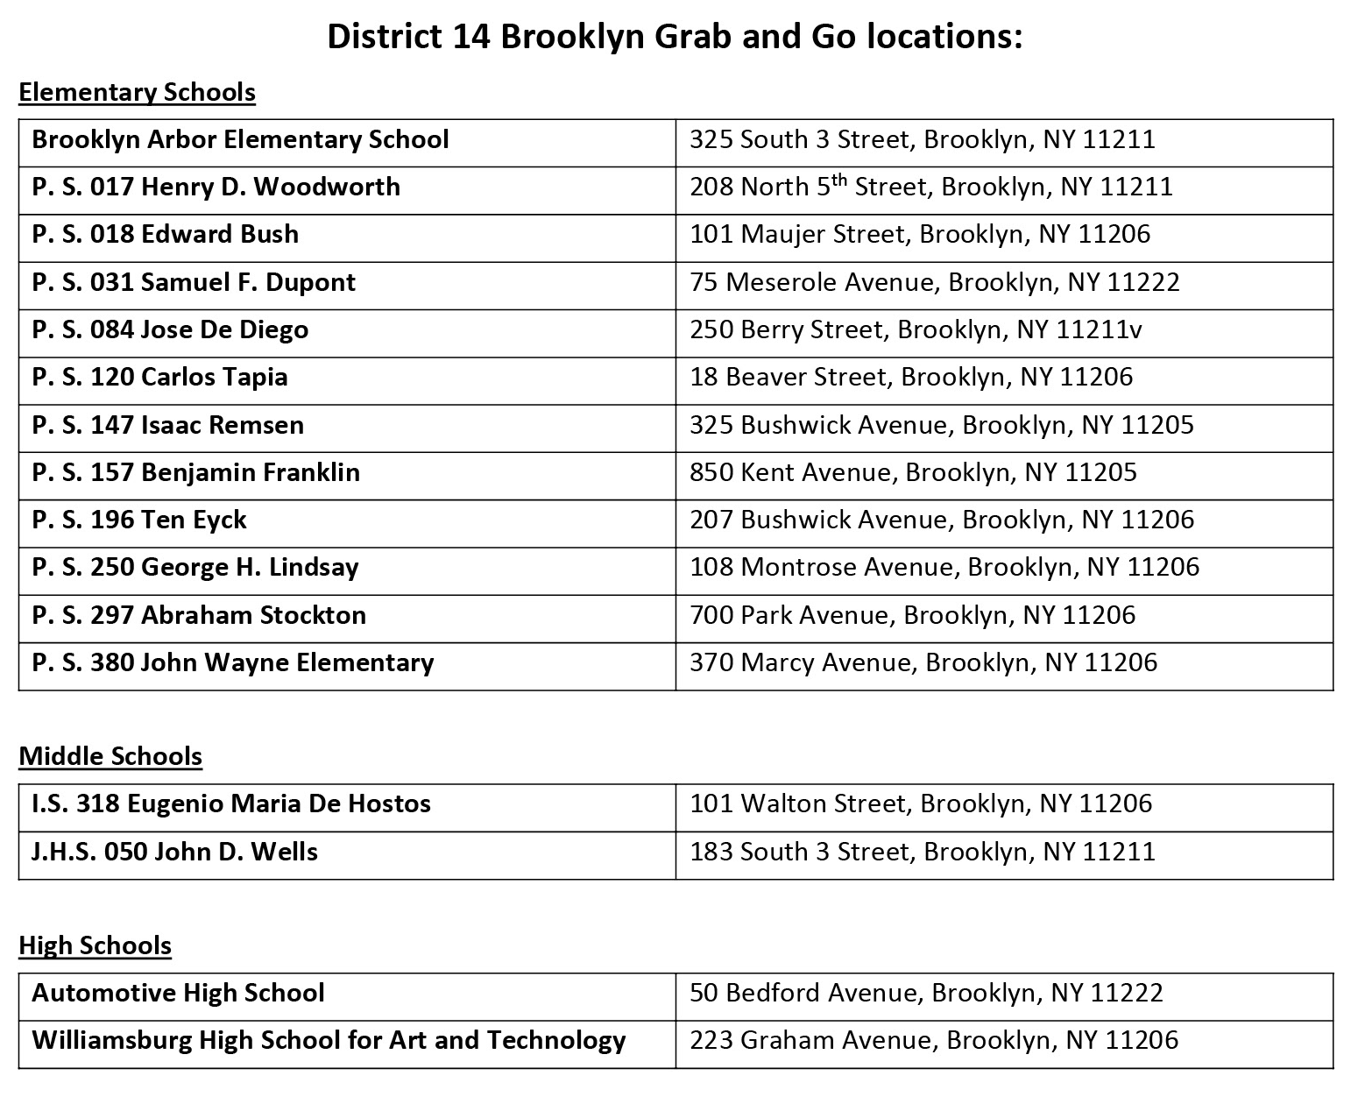
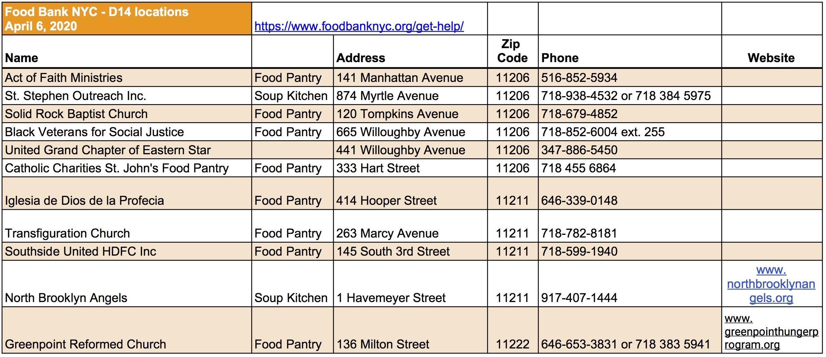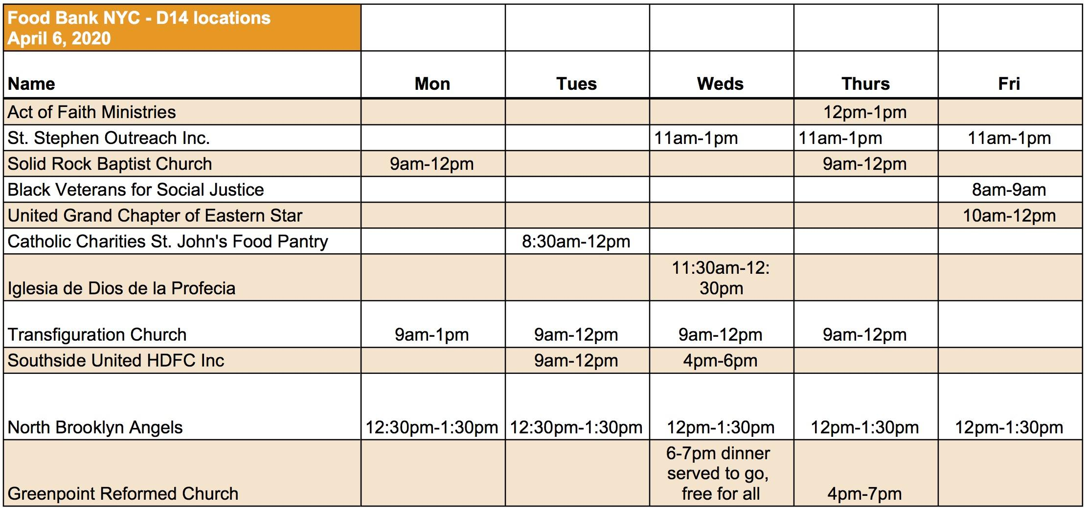

City Food Resources
- Call the Emergency FoodLine at 866-888-8777. This is an automated hotline available 24 hours a day, 7 days a week.
Or go to https://www1.nyc.gov/site/hra/help/food-assistance.page

Plentiful Pantry App w/City Harvest - Locate and connect with food pantries across this city.
The app is in 9 languages, and includes 170 pantries across all 5 boroughs.
- Text “FOOD” to 726879

To access SNAP online ordering
You can now use your Supplemental Nutrition Assistance Program (SNAP) benefits to shop online for groceries, and have them delivered to you. Use your EBT card to shop at these participating stores: Amazon, ShopRite, Walmart Note: SNAP benefits cannot be used to pay delivery fees. Be sure to confirm an online store delivers to your home address.
- Go to https://www1.nyc.gov/site/hra/help/snap-online-shopping.page

World Central Kitchen (WCK) #ChefsForAmerica is distributing fresh, individually packaged grab-and-go meals to local families at the designated sites listed below.
For more info: Call Senator Gournades Office: 718-238-6044

Pick up sites and schedules:
- Senator Gounardes Office: Mon & Thurs, 12-2pm
8018 5th Ave

- Cornerstone Baptist Church: Mon-Sat, 11-2pm
574 Madison St.

- Bushwick Generator: Mon-Sat, 12-1pm
215 Moore St.

- Elite Brooklyn: Mon, Weds, Fri, 12pm-1:30pm
128 Metropolitan Ave

